**Practical No. 3**

**Aim: To verify operation of NAND & NOR gate as universal gates.**

**Apparatus:** connection wires, power supply, power project board, LED, ICs

**Theory:**

The AND, OR and NOT gates are the basic building blocks of digital system. These gates are known as basic gates. Any digital circuit of any complexity can be built using only these three gates. A universal gate is a gate which alone can be used to build any logic circuit. As the basic gates can be realized using only NAND gates or using only NAND gates or using only NOR gates. So NAND gate and NOR gate are also known as Universal gates. The following design diagrams are shown the realization of AND, OR and NOT function using either only NAND gates or only NOR gates.

**NAND gate as NOT gate:**

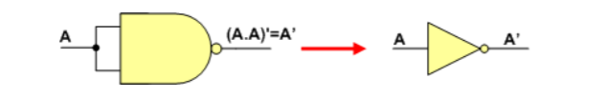

**Circuit Design:**

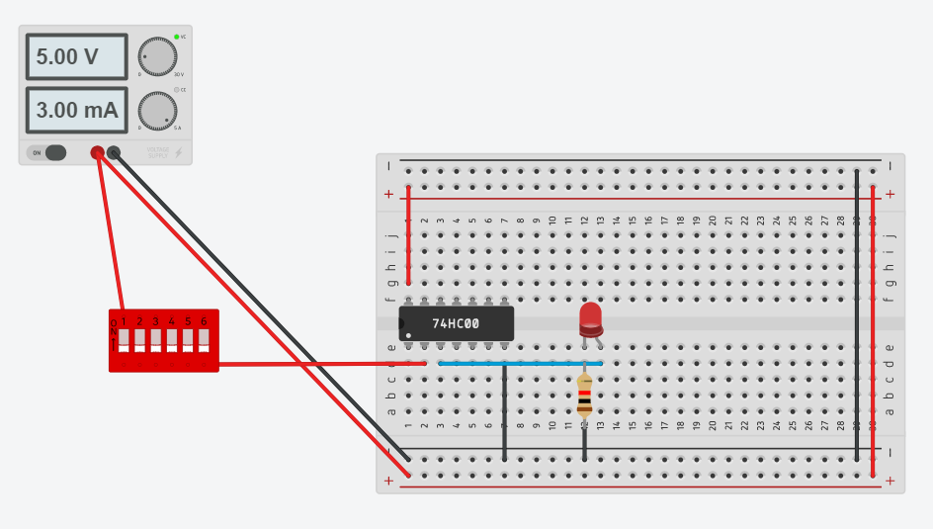

**NAND gate as AND gate:**

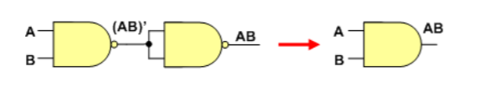

**Circuit Design:**

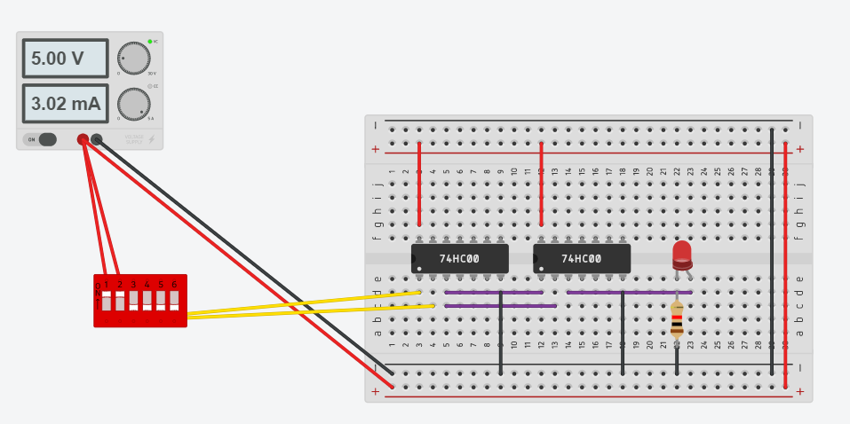

**NAND gate as OR gate**

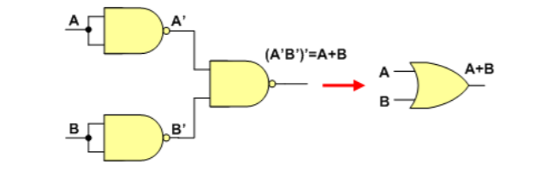

**Circuit Design:**

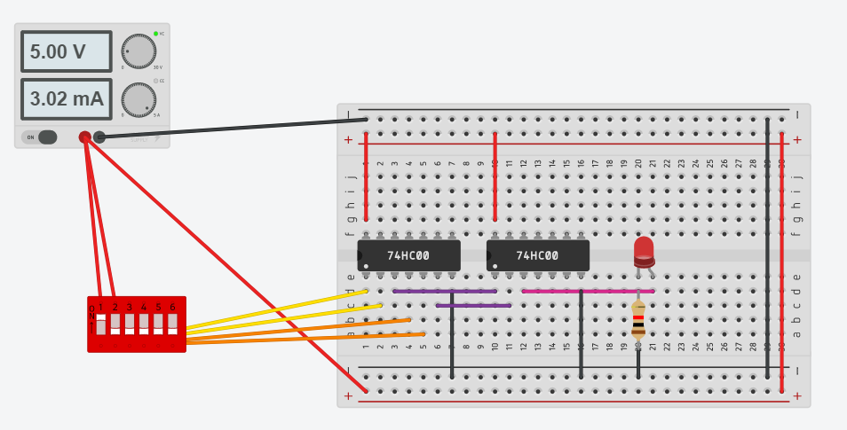

**NOR gate as NOT gate:**

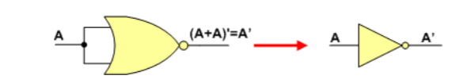

**Circuit Design:**

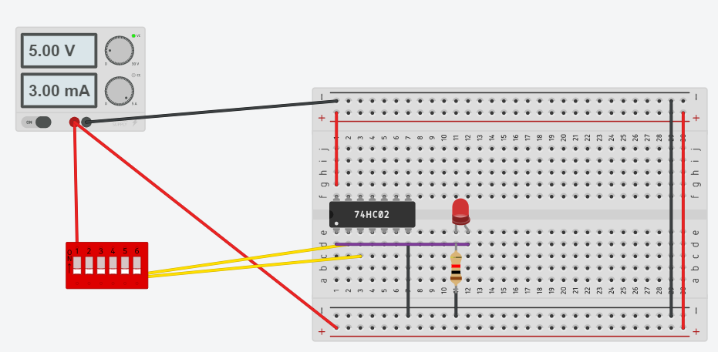

**NOR gate as OR gate:**

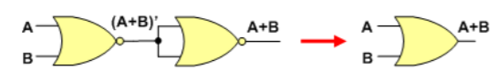

**Circuit Design:**

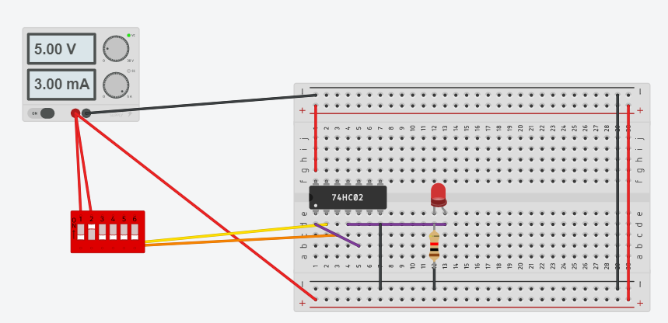

**NOR gate as AND gate:**

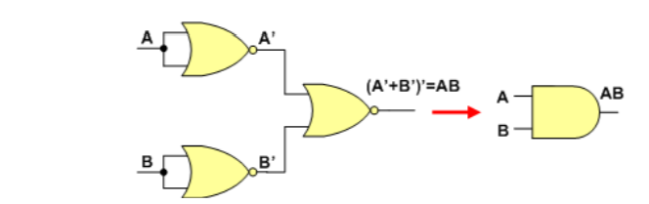

**Circuit Design:**

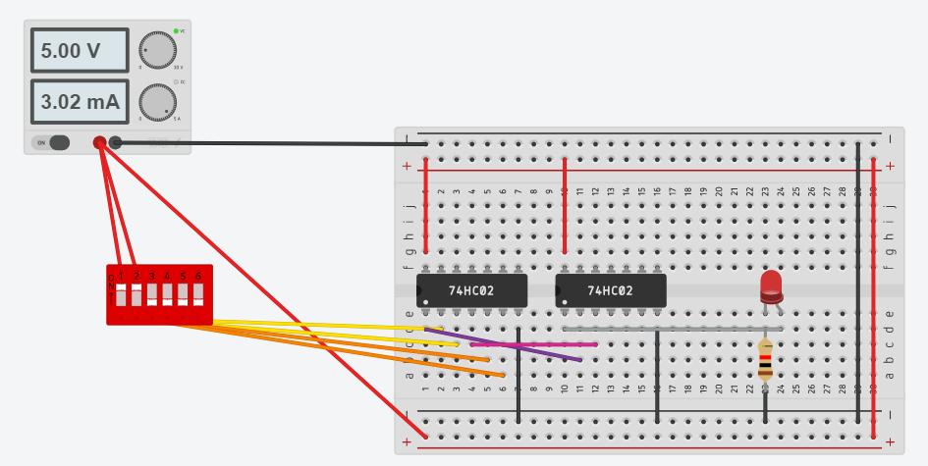

**Procedure:**



1. Mount ICs 7400, 7402 on the power project board.
2. Connect pin number 7 and 14 of all ICs to ground and +5V supply respectively.
3. Make the connection as shown in the logic diagram.
4. Verify the truth table of all the data.

**Conclusion:**

By performing the above practical, we came to know about how just by using NAND gate or NOR gate we can design the entire circuit.

Thus, NAND and NOR are universal gates**.**